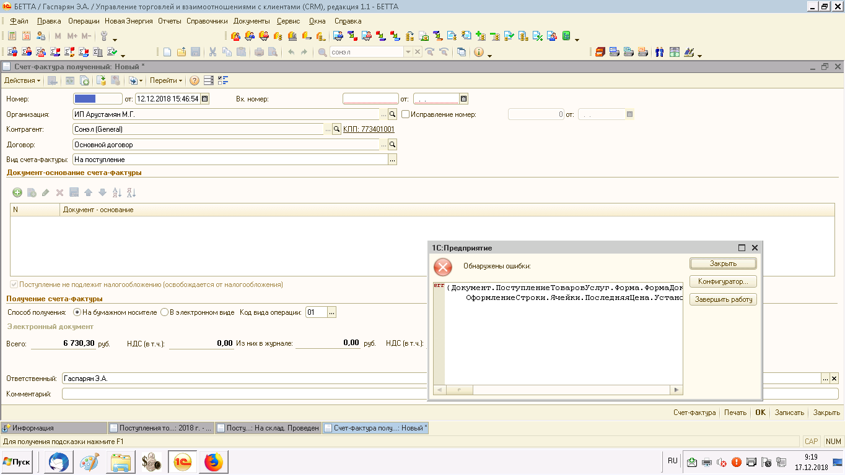
НОВОЕ ЗАДАНИЕ!
Дисциплина: Английский язык
для специальности: 54.02.01 Дизайн (по отраслям) Дизайн среды, Дизайн графики, 2 КУРС, ГРУППЫ ДС-181, ДС-182, ДС-183, ДГ-184
ПРАКТИЧЕСКИЕ И ДОМАШНИЕ ЗАДАНИЯ НА УЧЕБНЫЕ ЗАНЯТИЯ (ЧТЕНИЕ И ПИСЬМЕННЫЙ ПЕРЕВОД ТЕКСТОВ, ВЫПОЛНЕНИЕ УПРАЖНЕНИЙ)
Madame Tussaud's
Every visitor to London knows who Madame Tussaud is — or was. And almost every visitor has seen her, an old lady of 81, standing at the entrance of her own exhibition. She is made of wax, like all the models of people in this museum. There are a lot of halls in the museum. The first room is the "Garden Party". Beneath a star-spangled sky, under an oak-tree, figures from the worlds of sports and the media enjoy a friendly drink and chat. There are statues of A. Schwarzenegger, E. Taylor and others there. "200 Years" room covers the history of Madame Tussaud's over the last two centuries, and shows the developing of new technology during that time. There are also other rooms, such as: "Legends and Superstars", rooms with popular music singers, the members of royal families and military leaders. There is the "Chamber of Horrors" which amuses visitors very much. "The Spirit of London" is a magnificent journey through London's history. The cabs travel past the figure of W. Shakespeare, Sir Christopher Wren, who directs the building of St Paul's Cathedral. It's not easy to tell about all interesting things one can see in the museum. This is the place that is worth visiting.
British theatres

Until reccently the history of the english theatre has been buildaround actors rather then companies. It was hard to find any Londontheatre that even had a consistent policy. There is no permanent staffin British theatres. A play is rehearsed for a few weeks by a company ofactors working together mostly for the first time and it is allowed torun as long as it draws the odious and pays it's way.
Another peculiarity of the theatres in Great Britain is as follows:there are two kinds of seats, which can be booked in advance(bookable), and unbookable ones have no numbers and the spectatorsoccupy them on the principle: first come - first served. In ancienttimes plays were acted inside churches and later on the market places.
The first theatre in England "The Blackfries" was built in 1576, and "TheGlobe", which is closely connected with WilliamShakespeare, was built in 1599. Speaking about our times we should first of all mention"The English National theatre","The Royal Shakespeare company" and"Covent Garden".
"Covent Garden" used to be a fashionable promenade - it was, beforethen, a convent garden - but when it became overrun with flower-sellers,orange-vendors and vegetable-growers, the people moved to more exclusivesurroundings farther west, such as "St. Jame's Square".
The first "Covent Garden theatre" was built in 1732. It was burntdown in 1808 and rebuilt exactly a year after. It opened in September1809, with Shakespeare's "Macbeth". Since the middle of the last century"Covent Garden" became exclusively devoted to opera.
Now "Covent Garden" is busier than ever, it is one of the fewwell-known opera houses open for 11 months of the year and it employsover 600 people from both the Opera company and the Royal Ballet.

Oscar
It is well-known that Oscars are awarded by the Academy of Motion Picture Arts and Sciences. It is a professional honorary organization composed of over 6,000 motion picture artists and craftsmen and women. The Academy was organized in May, 1927, as a nonprofit corporation chartered under the laws of California.
A popular story has been that an Academy librarian and eventual executive director, Margaret Herrick, thought the statuette resembled her Uncle Oscar and said so, and that as a result the Academy staff began referring to it as Oscar. No hard evidence exists to support that tale, but in any case, by the sixth Awards Presentation in 1934, Hollywood columnist Sidney Skolsky used the name in his column in reference to Katharine Hepburn's first Best Actress win. The Academy itself didn't use the nickname officially until 1939.
The Oscar is a tin and copper statuette of a naked man holding a sword and standing on a reel of film. The award weighs 8 1/2 pounds and is plated with gold. Since the list of winners is kept secret until the telecast, the awards handed out on television are blanks. The Academy reclaims the statuettes the morning after the telecast and has them engraved before they are shipped back to the anxious recipients. The personalized engraving is on a small plaque attached to the pedestal on which Oscar stands. The engraving includes the year, the award category and the name of the recipient. Each statuette is also engraved with a serial number on the back of its base.
Since its conception, the Oscar statuette has met exacting uniform standards - with a few notable exceptions. In the 1930s, juvenile players received miniature replicas of the statuette; ventriloquist Edgar Bergen was presented with a wooden statuette with a moveable mouth; and Walt Disney was honored with one full-size and seven miniature statuettes on behalf of his animated feature Snow White and the Seven Dwarfs. Between 1942 and 1944, in support of the war effort, Oscars were made of plaster. After the War, winners turned in the temporary awards for golden Oscar statuettes.
Watching the Oscar telecast has become the equivalent of a secular religious experience for many. The Oscars occur every year at the same time and there are strict rules and regulations and hundreds of commandments. The Oscar itself has become a sacred icon within the industry.

Photography
Photography is very popular today, but there is a question, if it is art or nor. Let's discuss it.
Some people think that it is art, others that it is separate branch. On the one hand, photography and art are closely connected. Many painters used photographs in their works. Also, photography and painting have the same aim: People use them to document the life to show the world, the way painter or photographer see it. On the other hand, photography is the modern science. It is different from art, because it mostly documents the events and the world. Photographers can't transfer their thoughts and imagination to the photographs, and painters can do it, they can create their own world.
As for me, I think that photography can be considered as the part of the art. Of course, it is a new way of transferring artist's imagination, but it is still art, and it is closely connected with it. They have the same aims, they just realize it in different ways.

Past Simple or Present Perfect. Exercises.
Упражнение 1. Complete the pairs of sentences. Use the Present Perfect in one sentence and the Past Simple in the other.
- I (know) _______ her for six years.
I (know) _______ him when I was at school.
- He (live) _______ in Paris from 1997 to 2000.
He (live) _______ in New York since 2001.
- Where's Pete? I (not see) _______ him for ages.
I (not see) _______ Pete last night.
- We (be) _______ at primary school from 1993 to 1998.
We (be) _______ in this class since September.
- I (not watch) _______ this video yet.
I (not watch) _______ a video at the weekend.

Упражнение 2. Put the verbs in brackets in the Past Simple or in the Present Perfect.
1. I ________ (never/ be) to the USA. I ______ (want) to go there last summer but I couldn’t.
2. He _______ (live) in this street all his life.
3. His father ________ (come back) to London last Sunday.
4. Yan __________ (write) a letter to Nick two days ago.
5. He ________ (send) his letter yesterday.
6. They ________ (just/ buy) some postcards.

Упражнение 3. Fill in last night, ever, ago, just, yet, always in the right place.
1. Nick’s uncle went to Russia 3 years.
2. Mr. Rambler has come back from Belarus.
3. Nick has wanted to visit Belarus.
4. Mr. Rambler saw Yan.
5. They haven’t visited this old castle.
6. Have you been to England?

Упражнение 4. Choose the correct option.
- She has /‘s had a moped since she was 15.
- We took /‘ve taken a taxi to town that morning.
- We played /'ve played volleyball last night
- I'm really hungry. I didn’t eat / haven’t eaten since last night.
- They visited/ ‘ve visited Colorado last summer.

Упражнение 5. Put the verbs in brackets in the Past Simple or in the Present Perfect.
1. Maria (get) ______ some bad news last week. She (be) ______ sad since she (get) ______ the bad news.
2. I (start) ______ school when I was five years old. I (be) ______ at school since I (be) ______ five years old.
3. I (change) ______ my job three times this year.
4. I (change) ______ my job three times last year.
5. The weather was hot and dry for many weeks. But two days ago it (rain) ______.
6. Tom (break) ______ his leg five days ago. He’s in hospital. He (be) ______ in hospital since he (break) ______ his leg.
7. Are you going to finish your work before you go to bed? — I (finish) ______ it (already). I (finish) ______ my work two hours ago.

Упражнение 6. Put the verbs in brackets in the Past Simple or in the Present Perfect.
1. I (have, just) ______ a nice pot of coffee. Would you like a cup?
2. I (see, not) ______ Steve this morning yet.
3. Carol and I are old friends. I (know) ______ her since I (be) ______ a freshman in high school.
4. Maria (have) ______ a lot of problems since she (come) ______ to this country.
5. I (go) ______ to Paris in 2003 and 2006.
6. A car came round the corner and I (jump) ______ out of the way.
7. Don’t throw the paper away because I (not to read) ______ it yet.
8. Is Jim going to eat lunch with us today? — No. He (eat) ______ (already).He (eat) ______ lunch an hour ago.
9. Since we (start) ______ doing this exercise, we (complete) ______ some sentences.
10. I (be) ______ never to Italy.

Упражнение 7. Put the verbs in brackets in the Past Simple or in the Present Perfect.
1. You (ever work) ______ in a shop?
2. I (work) ______ at my uncle’s shop when I was younger.
3. It’s the first time I (be) ______ on a ship.
4. Ann is looking for her key. She can’t find it. She (lose) ______ her key.
5. How many symphonies Beethoven (compose) ______?
6. Look! Somebody (spill) ______ ink on the notebook.
7. You (have) ______ a holiday this year yet?
8. You (see) ______ any good films recently?
9. He (have, not) ______ any problems since he (come ) ______ here.

Упражнение 8. Раскройте скобки, употребляя глаголы в Past Simple или Present Perfect
1. I (cut) ______ some flowers from my garden yesterday. I (cut) ______ lots of flowers from my garden so far this summer.
2. I (not / see) ______ Tom lately.
3. The artist (draw) ______ a picture of sunset yesterday. She (draw) ______ many pictures of sunsets in her lifetime.
4. I (feed) ______ birds at the park yesterday. I (feed) ______ birds at the park every day since I (lose) ______ my job.
5. Ann (wake up) ______ late and (miss) _______ her breakfast on Monday.
6. I (forget) ______ to turn off the stove after dinner. I (forget) ______ to turn off the stove a lot of times in my lifetime.
7. The children (hide) ______ in the basement yesterday. They (hide) ______ in the basement often since they (discover) ______ a secret place there.
8. The baseball player (hit) ______ the ball out of the stadium yesterday. He (hit) ______ a lot of homeruns since he (join) ______ our team.
9. We first (meet) ______ in 2001. So we (know) _______ each other for 8 years.

Упражнение 9. Put the verbs in brackets in the Past Simple or in the Present Perfect.
1. She (change) ______ a lot since she left school.
2. I (see) ______ this film and I don’t want to see it again.
3. Jazz (originate) ______ in the United States around 1900.
4. Tom Hanks (win) ______ an Oscar several times already.
5. Long ago, they (build) ______ most houses out of wood.
6. Scientists still (not/find) ______ a cure for cancer.
7. Sean (eat, never) ______ Chinese food before.
8. In my first job, I (be) ______ responsible for marketing.
9. The last job I (apply) ______ for required applicants to speak some Japanese.
10. The first modern Olympics (take) ______ place in Athens more than a hundred years ago.
11. I am writing in connection with the advertisement which (appear) ______ in December.

Упражнение 10. Complete the sentences. Use the Present Perfect or the Past Simple.
My family and I (move) from London to Cardiff last summer, so we (live) in Cardiff for seven months now. I miss my friends in London. My best friend is called Megan. We (meet) at primary school, so I (know) her for nine years. Unfortunately, I (not see) her since last summer.
I go to Greystone Secondary School in Cardiff. I (be) at the school since last September. At first I (not like) it because I (not have) any friends here. But the students in my class are really nice and I'm happy here now.

Упражнение 11. Correct the mistakes in these sentences.
- We lived here since 1997.
- I've been ill since two days.
- How long do you know him?
- Susie has seen a good film last night.
- We've finished our homework just.
- I've already wrote three letters.

Упражнение 12. Complete the sentences. Use the Present Perfect or the Past Simple.
Helen: That's a nice tennis racket. Is it new?
Andy: No, (I/have) ________ it for about a year, but ( I/not play) _______ with it very much. ( I/buy) ________ it in Florida.
Helen: When ( you/go) ________ to America?
Andy: ( I/go) ________ there with my family in the spring.
Helen: What was it like?
Andy: Great! (I/stay) ___________ with my penfriend.
Helen: Is your penfriend American?
Andy: Yes. ( I/have) ________ an American penfriend for two years. (he/come) __________ to England last summer.
Helen: (I/not meet) _______ him.
Andу: No, (you/be) ______ on holiday in Turkey.

Упражнение 13. Choose the correct form of the verb.
- We went/ ‘ve been to the seaside last summer.
- I finished / ‘ve finished my homework. Can I go out now?
- I was /‘ve been ill three months ago.
- Have you been / Did you to the shop? I need some stamps.
- My hobby is fishing. I’ve caught / caught a lot of fish.
- Jenny is in Oxford today, but she was /has been in London yesterday.
- I played /'ve played basketball when I was younger, but l don’t play now.
- I’ve already seen / already saw 'Shrek'.
- Julie has been / was ill since Tuesday.
- I didn't see / haven't seen Josh since 1998.
- We've stayed / stayed at our grandparents for three days. We arrived home yesterday.
- The dog went / has gone to sleep an hour ago.
- I had / ‘ve had a cat for two years. Its name is Willis.
- I’ve waited / waited for a bus for twenty minutes. Then I decided to walk.

